**SMS Sequences**

Please find below the configuration for an SMS sequence asking if a potential student is interested in Marketing training or Accounting training. Depending on their answer, we create a tag in Infusionsoft that will then email them further information on either Marketing or Accounting courses.

Please be aware that to submit this assignment requires creating and paying for a Twillio account. I have created and paid for an account, however the final step in the process (saving the sequence) requires subscription to a telephone number. As a telephone number is an additional cost which I have no need for at this stage, I am not able to provide a screenshot of the very last step (saving), however I do understand exactly how it works.

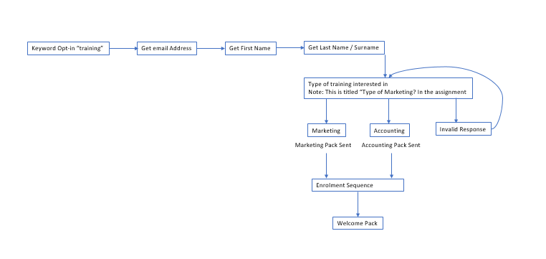

Please find configuration below.

