**Integrate Infusionsoft with GoToWebinar using PlusThis**

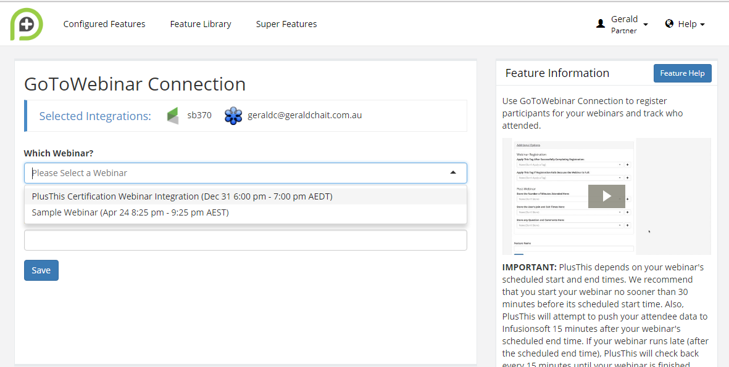

**Custom Fields created in Infusionsoft**

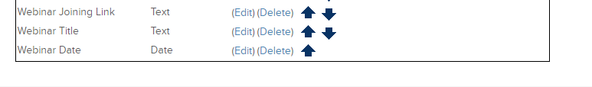

**Relevant tags created within Infusionsoft**

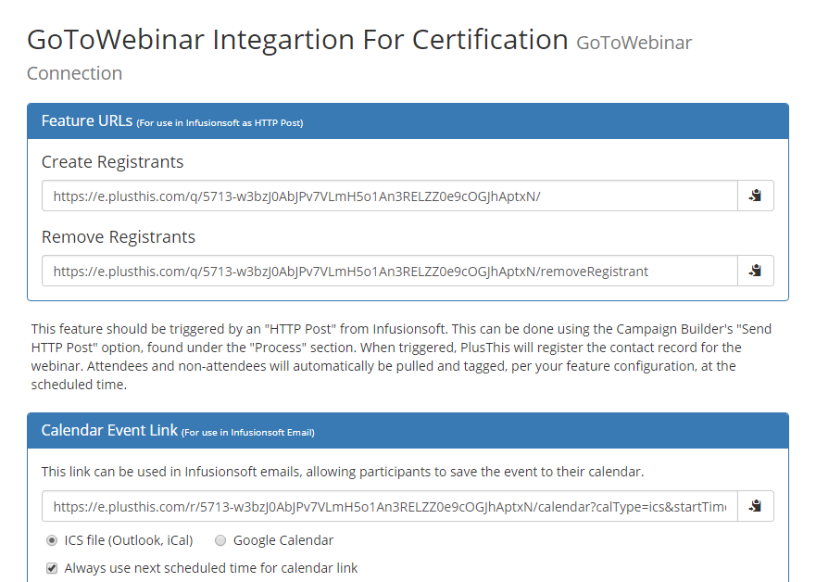

Campaign within Infusionsoft

